**Institute of Engineering & Management**

**Department of Computer Science & Engineering**

**Network Lab for 3rd year 6th semester 2019**

**Code: CS 692**

**Date:** 17/02/19

**WEEK-3**

**Assignment-1**

**Problem Statement:** Create a network and share IP address using DHCP.

**Screen-Shot:**

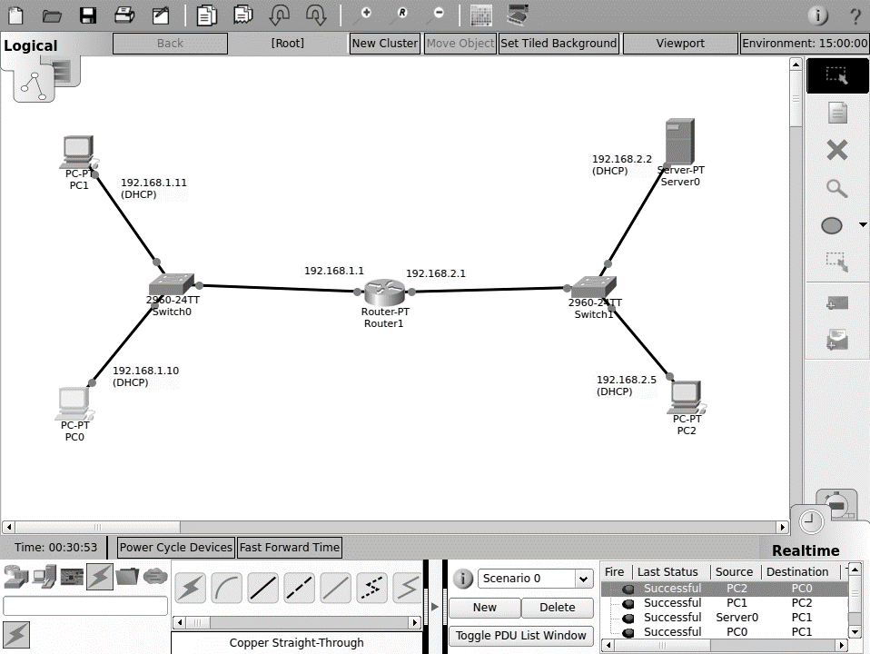

**CLI code:**

Router>en

Router#config terminal

Enter configuration commands, one per line. End with CNTL/Z.

Router(config)#interface f 0/0

Router(config-if)#ip address 192.168.1.1 255.255.255.0

Router(config-if)#no shutdown

Router(config-if)#

%LINK-5-CHANGED: Interface FastEthernet0/0, changed state to up

%LINEPROTO-5-UPDOWN: Line protocol on Interface FastEthernet0/0, changed state to up

Router(config-if)#exit

Router(config)#interface f 1/0

Router(config-if)#ip address 192.168.2.1 255.255.255.0

Router(config-if)#no shutdown

Router(config-if)#

%LINK-5-CHANGED: Interface FastEthernet1/0, changed state to up

%LINEPROTO-5-UPDOWN: Line protocol on Interface FastEthernet1/0, changed state to up

exit

Router(config)#router rip

Router(config-router)#exit

Router(config)#interface f 0/0

Router(config-if)#ip helper-

Router(config-if)#ip helper-address 192.168.2.2

Router(config-if)#

**Assignment-2**

**Problem Statement:** Create a network and introduce a DNS in that network.

**Screen-Shot:**

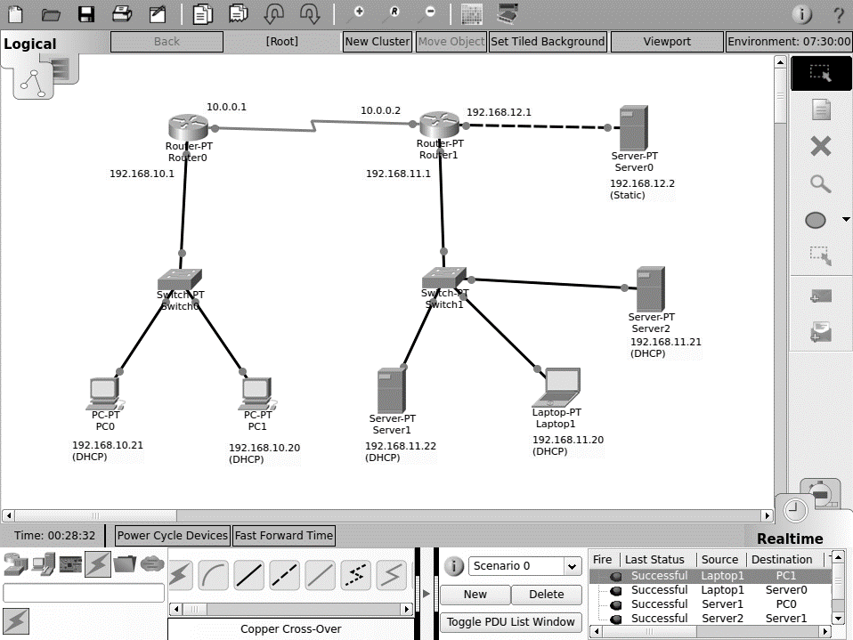

**Fig: Network**

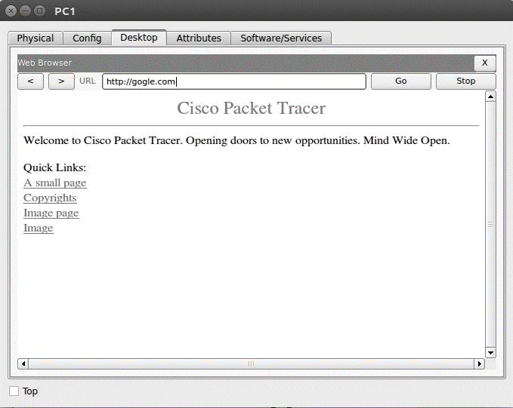

**Fig: Browser in a terminal**

**CLI code:**

**Router-0:**

Router>en

Router#config terminal

Enter configuration commands, one per line. End with CNTL/Z.

Router(config)#interface f0/0

Router(config-if)#ip address 192.168.10.1 255.255.255.0

Router(config-if)#no shutdown

Router(config-if)#

%LINK-5-CHANGED: Interface FastEthernet0/0, changed state to up

%LINEPROTO-5-UPDOWN: Line protocol on Interface FastEthernet0/0, changed state to up

Router(config-if)#exit

Router(config)#interface se2/0

Router(config-if)#ip address 10.0.0.1 255.0.0.0

Router(config-if)#clock rate 64000

Router(config-if)#no shutdown

%LINK-5-CHANGED: Interface Serial2/0, changed state to down

Router(config-if)#exit

Router(config)#interface f0/0

Router(config-if)#

%LINK-5-CHANGED: Interface Serial2/0, changed state to up

%LINEPROTO-5-UPDOWN: Line protocol on Interface Serial2/0, changed state to up

Router(config-if)#ip helper-address 192.168.12.2

Router(config-if)#exit

Router(config)#router rip

Router(config-router)#network 192.168.10.0

Router(config-router)#network 10.0.0.0

Router(config-router)#exit

Router(config)#

**Router-1:**

Router>en

Router#config terminal

Enter configuration commands, one per line. End with CNTL/Z.

Router(config)#interface se2/0

Router(config-if)#ip address 10.0.0.2 255.0.0.0

Router(config-if)#no shutdown

Router(config-if)#

%LINK-5-CHANGED: Interface Serial2/0, changed state to up

%LINEPROTO-5-UPDOWN: Line protocol on Interface Serial2/0, changed state to up

Router(config-if)#exit

Router(config)#interface f1/0

Router(config-if)#ip address 192.168.12.1 255.255.255.0

Router(config-if)#no shutdown

Router(config-if)#

%LINK-5-CHANGED: Interface FastEthernet1/0, changed state to up

%LINEPROTO-5-UPDOWN: Line protocol on Interface FastEthernet1/0, changed state to up

Router(config-if)#exit

Router(config)#interface f0/0

Router(config-if)#ip address 192.168.11.1 255.255.255.0

Router(config-if)#ip helper-address 192.168.12.2

Router(config-if)#no shutdown

Router(config-if)#

%LINK-5-CHANGED: Interface FastEthernet0/0, changed state to up

%LINEPROTO-5-UPDOWN: Line protocol on Interface FastEthernet0/0, changed state to up

Router(config-if)#exit

Router(config)#router rip

Router(config-router)#

Router(config-router)#network 192.168.11.0

Router(config-router)#network 192.168.12.0

Router(config-router)#network 10.0.0.0

Router(config-router)#exit

Router(config)#